Speexx Campus
账号递交书账号递交书账号递交书账号递交书
浙江外国语学院

德普软件开发（上海）有限公司
2017/4/11

项目概况
直接客户： 浙江外国语学院
账号类型：Speexx Campus WEB版全级别账号（每个账号包含6个级别的课程）
账号数量：430个
课程目标语种：德语：50个；法语：100个；西班牙语：250个；意大利语：30个
课程用户语种：中文
课程有效期：单个课程自激活之日起90天
递交方式：在线递交
技术支持：二级在线支持

德语 |  | 德语
用户名 | 初始密码 | 用户名 | 初始密码
ZISUGE1001 | ZISUGE1001 | ZISUGE1026 | ZISUGE1026
ZISUGE1002 | ZISUGE1002 | ZISUGE1027 | ZISUGE1027
ZISUGE1003 | ZISUGE1003 | ZISUGE1028 | ZISUGE1028
ZISUGE1004 | ZISUGE1004 | ZISUGE1029 | ZISUGE1029
ZISUGE1005 | ZISUGE1005 | ZISUGE1030 | ZISUGE1030
ZISUGE1006 | ZISUGE1006 | ZISUGE1031 | ZISUGE1031
ZISUGE1007 | ZISUGE1007 | ZISUGE1032 | ZISUGE1032
ZISUGE1008 | ZISUGE1008 | ZISUGE1033 | ZISUGE1033
ZISUGE1009 | ZISUGE1009 | ZISUGE1034 | ZISUGE1034
ZISUGE1010 | ZISUGE1010 | ZISUGE1035 | ZISUGE1035
ZISUGE1011 | ZISUGE1011 | ZISUGE1036 | ZISUGE1036
ZISUGE1012 | ZISUGE1012 | ZISUGE1037 | ZISUGE1037
ZISUGE1013 | ZISUGE1013 | ZISUGE1038 | ZISUGE1038
ZISUGE1014 | ZISUGE1014 | ZISUGE1039 | ZISUGE1039
ZISUGE1015 | ZISUGE1015 | ZISUGE1040 | ZISUGE1040
ZISUGE1016 | ZISUGE1016 | ZISUGE1041 | ZISUGE1041
ZISUGE1017 | ZISUGE1017 | ZISUGE1042 | ZISUGE1042
ZISUGE1018 | ZISUGE1018 | ZISUGE1043 | ZISUGE1043
ZISUGE1019 | ZISUGE1019 | ZISUGE1044 | ZISUGE1044
ZISUGE1020 | ZISUGE1020 | ZISUGE1045 | ZISUGE1045
ZISUGE1021 | ZISUGE1021 | ZISUGE1046 | ZISUGE1046
ZISUGE1022 | ZISUGE1022 | ZISUGE1047 | ZISUGE1047
ZISUGE1023 | ZISUGE1023 | ZISUGE1048 | ZISUGE1048
ZISUGE1024 | ZISUGE1024 | ZISUGE1049 | ZISUGE1049
ZISUGE1025 | ZISUGE1025 | ZISUGE1050 | ZISUGE1050

法语 |  | 法语
用户名 | 初始密码 | 用户名 | 初始密码
ZISUFR1001 | ZISUFR1001 | ZISUFR1051 | ZISUFR1051
ZISUFR1002 | ZISUFR1002 | ZISUFR1052 | ZISUFR1052
ZISUFR1003 | ZISUFR1003 | ZISUFR1053 | ZISUFR1053
ZISUFR1004 | ZISUFR1004 | ZISUFR1054 | ZISUFR1054
ZISUFR1005 | ZISUFR1005 | ZISUFR1055 | ZISUFR1055
ZISUFR1006 | ZISUFR1006 | ZISUFR1056 | ZISUFR1056
ZISUFR1007 | ZISUFR1007 | ZISUFR1057 | ZISUFR1057
ZISUFR1008 | ZISUFR1008 | ZISUFR1058 | ZISUFR1058
ZISUFR1009 | ZISUFR1009 | ZISUFR1059 | ZISUFR1059
ZISUFR1010 | ZISUFR1010 | ZISUFR1060 | ZISUFR1060
ZISUFR1011 | ZISUFR1011 | ZISUFR1061 | ZISUFR1061
ZISUFR1012 | ZISUFR1012 | ZISUFR1062 | ZISUFR1062
ZISUFR1013 | ZISUFR1013 | ZISUFR1063 | ZISUFR1063
ZISUFR1014 | ZISUFR1014 | ZISUFR1064 | ZISUFR1064
ZISUFR1015 | ZISUFR1015 | ZISUFR1065 | ZISUFR1065
ZISUFR1016 | ZISUFR1016 | ZISUFR1066 | ZISUFR1066
ZISUFR1017 | ZISUFR1017 | ZISUFR1067 | ZISUFR1067
ZISUFR1018 | ZISUFR1018 | ZISUFR1068 | ZISUFR1068
ZISUFR1019 | ZISUFR1019 | ZISUFR1069 | ZISUFR1069
ZISUFR1020 | ZISUFR1020 | ZISUFR1070 | ZISUFR1070
ZISUFR1021 | ZISUFR1021 | ZISUFR1071 | ZISUFR1071
ZISUFR1022 | ZISUFR1022 | ZISUFR1072 | ZISUFR1072
ZISUFR1023 | ZISUFR1023 | ZISUFR1073 | ZISUFR1073
ZISUFR1024 | ZISUFR1024 | ZISUFR1074 | ZISUFR1074
ZISUFR1025 | ZISUFR1025 | ZISUFR1075 | ZISUFR1075
ZISUFR1026 | ZISUFR1026 | ZISUFR1076 | ZISUFR1076
ZISUFR1027 | ZISUFR1027 | ZISUFR1077 | ZISUFR1077
ZISUFR1028 | ZISUFR1028 | ZISUFR1078 | ZISUFR1078
ZISUFR1029 | ZISUFR1029 | ZISUFR1079 | ZISUFR1079
ZISUFR1030 | ZISUFR1030 | ZISUFR1080 | ZISUFR1080
ZISUFR1031 | ZISUFR1031 | ZISUFR1081 | ZISUFR1081
ZISUFR1032 | ZISUFR1032 | ZISUFR1082 | ZISUFR1082
ZISUFR1033 | ZISUFR1033 | ZISUFR1083 | ZISUFR1083
ZISUFR1034 | ZISUFR1034 | ZISUFR1084 | ZISUFR1084
ZISUFR1035 | ZISUFR1035 | ZISUFR1085 | ZISUFR1085
ZISUFR1036 | ZISUFR1036 | ZISUFR1086 | ZISUFR1086
ZISUFR1037 | ZISUFR1037 | ZISUFR1087 | ZISUFR1087
ZISUFR1038 | ZISUFR1038 | ZISUFR1088 | ZISUFR1088
ZISUFR1039 | ZISUFR1039 | ZISUFR1089 | ZISUFR1089
ZISUFR1040 | ZISUFR1040 | ZISUFR1090 | ZISUFR1090
ZISUFR1041 | ZISUFR1041 | ZISUFR1091 | ZISUFR1091
ZISUFR1042 | ZISUFR1042 | ZISUFR1092 | ZISUFR1092
ZISUFR1043 | ZISUFR1043 | ZISUFR1093 | ZISUFR1093
ZISUFR1044 | ZISUFR1044 | ZISUFR1094 | ZISUFR1094
ZISUFR1045 | ZISUFR1045 | ZISUFR1095 | ZISUFR1095
ZISUFR1046 | ZISUFR1046 | ZISUFR1096 | ZISUFR1096
ZISUFR1047 | ZISUFR1047 | ZISUFR1097 | ZISUFR1097
ZISUFR1048 | ZISUFR1048 | ZISUFR1098 | ZISUFR1098
ZISUFR1049 | ZISUFR1049 | ZISUFR1099 | ZISUFR1099
ZISUFR1050 | ZISUFR1050 | ZISUFR1100 | ZISUFR1100

西班牙语 |  | 西班牙语
用户名 | 初始密码 | 用户名 | 初始密码
ZISUSP1001 | ZISUSP1001 | ZISUSP1126 | ZISUSP1126
ZISUSP1002 | ZISUSP1002 | ZISUSP1127 | ZISUSP1127
ZISUSP1003 | ZISUSP1003 | ZISUSP1128 | ZISUSP1128
ZISUSP1004 | ZISUSP1004 | ZISUSP1129 | ZISUSP1129
ZISUSP1005 | ZISUSP1005 | ZISUSP1130 | ZISUSP1130
ZISUSP1006 | ZISUSP1006 | ZISUSP1131 | ZISUSP1131
ZISUSP1007 | ZISUSP1007 | ZISUSP1132 | ZISUSP1132
ZISUSP1008 | ZISUSP1008 | ZISUSP1133 | ZISUSP1133
ZISUSP1009 | ZISUSP1009 | ZISUSP1134 | ZISUSP1134
ZISUSP1010 | ZISUSP1010 | ZISUSP1135 | ZISUSP1135
ZISUSP1011 | ZISUSP1011 | ZISUSP1136 | ZISUSP1136
ZISUSP1012 | ZISUSP1012 | ZISUSP1137 | ZISUSP1137
ZISUSP1013 | ZISUSP1013 | ZISUSP1138 | ZISUSP1138
ZISUSP1014 | ZISUSP1014 | ZISUSP1139 | ZISUSP1139
ZISUSP1015 | ZISUSP1015 | ZISUSP1140 | ZISUSP1140
ZISUSP1016 | ZISUSP1016 | ZISUSP1141 | ZISUSP1141
ZISUSP1017 | ZISUSP1017 | ZISUSP1142 | ZISUSP1142
ZISUSP1018 | ZISUSP1018 | ZISUSP1143 | ZISUSP1143
ZISUSP1019 | ZISUSP1019 | ZISUSP1144 | ZISUSP1144
ZISUSP1020 | ZISUSP1020 | ZISUSP1145 | ZISUSP1145
ZISUSP1021 | ZISUSP1021 | ZISUSP1146 | ZISUSP1146
ZISUSP1022 | ZISUSP1022 | ZISUSP1147 | ZISUSP1147
ZISUSP1023 | ZISUSP1023 | ZISUSP1148 | ZISUSP1148
ZISUSP1024 | ZISUSP1024 | ZISUSP1149 | ZISUSP1149
ZISUSP1025 | ZISUSP1025 | ZISUSP1150 | ZISUSP1150
ZISUSP1026 | ZISUSP1026 | ZISUSP1151 | ZISUSP1151
ZISUSP1027 | ZISUSP1027 | ZISUSP1152 | ZISUSP1152
ZISUSP1028 | ZISUSP1028 | ZISUSP1153 | ZISUSP1153
ZISUSP1029 | ZISUSP1029 | ZISUSP1154 | ZISUSP1154
ZISUSP1030 | ZISUSP1030 | ZISUSP1155 | ZISUSP1155
ZISUSP1031 | ZISUSP1031 | ZISUSP1156 | ZISUSP1156
ZISUSP1032 | ZISUSP1032 | ZISUSP1157 | ZISUSP1157
ZISUSP1033 | ZISUSP1033 | ZISUSP1158 | ZISUSP1158
ZISUSP1034 | ZISUSP1034 | ZISUSP1159 | ZISUSP1159
ZISUSP1035 | ZISUSP1035 | ZISUSP1160 | ZISUSP1160
ZISUSP1036 | ZISUSP1036 | ZISUSP1161 | ZISUSP1161
ZISUSP1037 | ZISUSP1037 | ZISUSP1162 | ZISUSP1162
ZISUSP1038 | ZISUSP1038 | ZISUSP1163 | ZISUSP1163
ZISUSP1039 | ZISUSP1039 | ZISUSP1164 | ZISUSP1164
ZISUSP1040 | ZISUSP1040 | ZISUSP1165 | ZISUSP1165
ZISUSP1041 | ZISUSP1041 | ZISUSP1166 | ZISUSP1166
ZISUSP1042 | ZISUSP1042 | ZISUSP1167 | ZISUSP1167
ZISUSP1043 | ZISUSP1043 | ZISUSP1168 | ZISUSP1168
ZISUSP1044 | ZISUSP1044 | ZISUSP1169 | ZISUSP1169
ZISUSP1045 | ZISUSP1045 | ZISUSP1170 | ZISUSP1170
ZISUSP1046 | ZISUSP1046 | ZISUSP1171 | ZISUSP1171
ZISUSP1047 | ZISUSP1047 | ZISUSP1172 | ZISUSP1172
ZISUSP1048 | ZISUSP1048 | ZISUSP1173 | ZISUSP1173
ZISUSP1049 | ZISUSP1049 | ZISUSP1174 | ZISUSP1174
ZISUSP1050 | ZISUSP1050 | ZISUSP1175 | ZISUSP1175
ZISUSP1051 | ZISUSP1051 | ZISUSP1176 | ZISUSP1176
ZISUSP1052 | ZISUSP1052 | ZISUSP1177 | ZISUSP1177
ZISUSP1053 | ZISUSP1053 | ZISUSP1178 | ZISUSP1178
ZISUSP1054 | ZISUSP1054 | ZISUSP1179 | ZISUSP1179
ZISUSP1055 | ZISUSP1055 | ZISUSP1180 | ZISUSP1180
ZISUSP1056 | ZISUSP1056 | ZISUSP1181 | ZISUSP1181
ZISUSP1057 | ZISUSP1057 | ZISUSP1182 | ZISUSP1182
ZISUSP1058 | ZISUSP1058 | ZISUSP1183 | ZISUSP1183
ZISUSP1059 | ZISUSP1059 | ZISUSP1184 | ZISUSP1184
ZISUSP1060 | ZISUSP1060 | ZISUSP1185 | ZISUSP1185
ZISUSP1061 | ZISUSP1061 | ZISUSP1186 | ZISUSP1186
ZISUSP1062 | ZISUSP1062 | ZISUSP1187 | ZISUSP1187
ZISUSP1063 | ZISUSP1063 | ZISUSP1188 | ZISUSP1188
ZISUSP1064 | ZISUSP1064 | ZISUSP1189 | ZISUSP1189
ZISUSP1065 | ZISUSP1065 | ZISUSP1190 | ZISUSP1190
ZISUSP1066 | ZISUSP1066 | ZISUSP1191 | ZISUSP1191
ZISUSP1067 | ZISUSP1067 | ZISUSP1192 | ZISUSP1192
ZISUSP1068 | ZISUSP1068 | ZISUSP1193 | ZISUSP1193
ZISUSP1069 | ZISUSP1069 | ZISUSP1194 | ZISUSP1194
ZISUSP1070 | ZISUSP1070 | ZISUSP1195 | ZISUSP1195
ZISUSP1071 | ZISUSP1071 | ZISUSP1196 | ZISUSP1196
ZISUSP1072 | ZISUSP1072 | ZISUSP1197 | ZISUSP1197
ZISUSP1073 | ZISUSP1073 | ZISUSP1198 | ZISUSP1198
ZISUSP1074 | ZISUSP1074 | ZISUSP1199 | ZISUSP1199
ZISUSP1075 | ZISUSP1075 | ZISUSP1200 | ZISUSP1200
ZISUSP1076 | ZISUSP1076 | ZISUSP1201 | ZISUSP1201
ZISUSP1077 | ZISUSP1077 | ZISUSP1202 | ZISUSP1202
ZISUSP1078 | ZISUSP1078 | ZISUSP1203 | ZISUSP1203
ZISUSP1079 | ZISUSP1079 | ZISUSP1204 | ZISUSP1204
ZISUSP1080 | ZISUSP1080 | ZISUSP1205 | ZISUSP1205
ZISUSP1081 | ZISUSP1081 | ZISUSP1206 | ZISUSP1206
ZISUSP1082 | ZISUSP1082 | ZISUSP1207 | ZISUSP1207
ZISUSP1083 | ZISUSP1083 | ZISUSP1208 | ZISUSP1208
ZISUSP1084 | ZISUSP1084 | ZISUSP1209 | ZISUSP1209
ZISUSP1085 | ZISUSP1085 | ZISUSP1210 | ZISUSP1210
ZISUSP1086 | ZISUSP1086 | ZISUSP1211 | ZISUSP1211
ZISUSP1087 | ZISUSP1087 | ZISUSP1212 | ZISUSP1212
ZISUSP1088 | ZISUSP1088 | ZISUSP1213 | ZISUSP1213
ZISUSP1089 | ZISUSP1089 | ZISUSP1214 | ZISUSP1214
ZISUSP1090 | ZISUSP1090 | ZISUSP1215 | ZISUSP1215
ZISUSP1091 | ZISUSP1091 | ZISUSP1216 | ZISUSP1216
ZISUSP1092 | ZISUSP1092 | ZISUSP1217 | ZISUSP1217
ZISUSP1093 | ZISUSP1093 | ZISUSP1218 | ZISUSP1218
ZISUSP1094 | ZISUSP1094 | ZISUSP1219 | ZISUSP1219
ZISUSP1095 | ZISUSP1095 | ZISUSP1220 | ZISUSP1220
ZISUSP1096 | ZISUSP1096 | ZISUSP1221 | ZISUSP1221
ZISUSP1097 | ZISUSP1097 | ZISUSP1222 | ZISUSP1222
ZISUSP1098 | ZISUSP1098 | ZISUSP1223 | ZISUSP1223
ZISUSP1099 | ZISUSP1099 | ZISUSP1224 | ZISUSP1224
ZISUSP1100 | ZISUSP1100 | ZISUSP1225 | ZISUSP1225
ZISUSP1101 | ZISUSP1101 | ZISUSP1226 | ZISUSP1226
ZISUSP1102 | ZISUSP1102 | ZISUSP1227 | ZISUSP1227
ZISUSP1103 | ZISUSP1103 | ZISUSP1228 | ZISUSP1228
ZISUSP1104 | ZISUSP1104 | ZISUSP1229 | ZISUSP1229
ZISUSP1105 | ZISUSP1105 | ZISUSP1230 | ZISUSP1230
ZISUSP1106 | ZISUSP1106 | ZISUSP1231 | ZISUSP1231
ZISUSP1107 | ZISUSP1107 | ZISUSP1232 | ZISUSP1232
ZISUSP1108 | ZISUSP1108 | ZISUSP1233 | ZISUSP1233
ZISUSP1109 | ZISUSP1109 | ZISUSP1234 | ZISUSP1234
ZISUSP1110 | ZISUSP1110 | ZISUSP1235 | ZISUSP1235
ZISUSP1111 | ZISUSP1111 | ZISUSP1236 | ZISUSP1236
ZISUSP1112 | ZISUSP1112 | ZISUSP1237 | ZISUSP1237
ZISUSP1113 | ZISUSP1113 | ZISUSP1238 | ZISUSP1238
ZISUSP1114 | ZISUSP1114 | ZISUSP1239 | ZISUSP1239
ZISUSP1115 | ZISUSP1115 | ZISUSP1240 | ZISUSP1240
ZISUSP1116 | ZISUSP1116 | ZISUSP1241 | ZISUSP1241
ZISUSP1117 | ZISUSP1117 | ZISUSP1242 | ZISUSP1242
ZISUSP1118 | ZISUSP1118 | ZISUSP1243 | ZISUSP1243
ZISUSP1119 | ZISUSP1119 | ZISUSP1244 | ZISUSP1244
ZISUSP1120 | ZISUSP1120 | ZISUSP1245 | ZISUSP1245
ZISUSP1121 | ZISUSP1121 | ZISUSP1246 | ZISUSP1246
ZISUSP1122 | ZISUSP1122 | ZISUSP1247 | ZISUSP1247
ZISUSP1123 | ZISUSP1123 | ZISUSP1248 | ZISUSP1248
ZISUSP1124 | ZISUSP1124 | ZISUSP1249 | ZISUSP1249
ZISUSP1125 | ZISUSP1125 | ZISUSP1250 | ZISUSP1250

意大利语 |  | 意大利语
用户名 | 初始密码 | 用户名 | 初始密码
ZISUIT1001 | ZISUIT1001 | ZISUIT1016 | ZISUIT1016
ZISUIT1002 | ZISUIT1002 | ZISUIT1017 | ZISUIT1017
ZISUIT1003 | ZISUIT1003 | ZISUIT1018 | ZISUIT1018
ZISUIT1004 | ZISUIT1004 | ZISUIT1019 | ZISUIT1019
ZISUIT1005 | ZISUIT1005 | ZISUIT1020 | ZISUIT1020
ZISUIT1006 | ZISUIT1006 | ZISUIT1021 | ZISUIT1021
ZISUIT1007 | ZISUIT1007 | ZISUIT1022 | ZISUIT1022
ZISUIT1008 | ZISUIT1008 | ZISUIT1023 | ZISUIT1023
ZISUIT1009 | ZISUIT1009 | ZISUIT1024 | ZISUIT1024
ZISUIT1010 | ZISUIT1010 | ZISUIT1025 | ZISUIT1025
ZISUIT1011 | ZISUIT1011 | ZISUIT1026 | ZISUIT1026
ZISUIT1012 | ZISUIT1012 | ZISUIT1027 | ZISUIT1027
ZISUIT1013 | ZISUIT1013 | ZISUIT1028 | ZISUIT1028
ZISUIT1014 | ZISUIT1014 | ZISUIT1029 | ZISUIT1029
ZISUIT1015 | ZISUIT1015 | ZISUIT1030 | ZISUIT1030

登陆方式
- 输入网址：portal.speexx.cn，点击网站上学生登录进入。
- 输入用户名及密码。
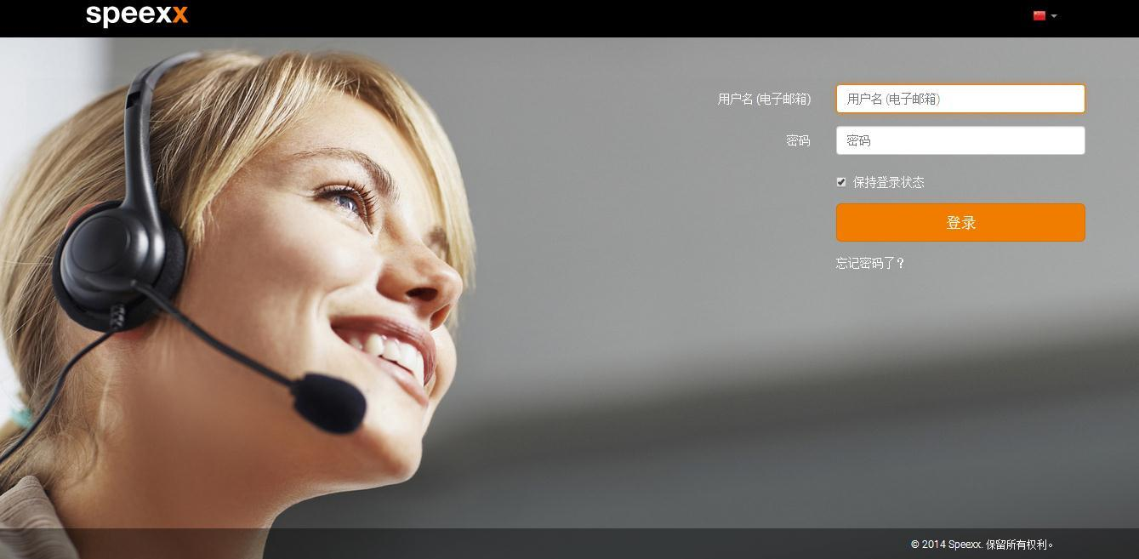

修改密码及个人资料
- 首次登陆时，需根据系统要求， 改密码并完善个人资料。
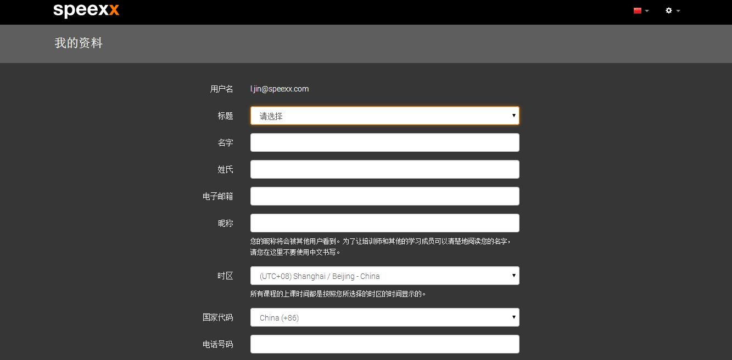

课程激活
-  账号包含Speexx Campus六个级别的课程及分级测 。
-  选择要学习的课程，单击确认后，即可激活。
-  课程有效期 激活日开始计算.
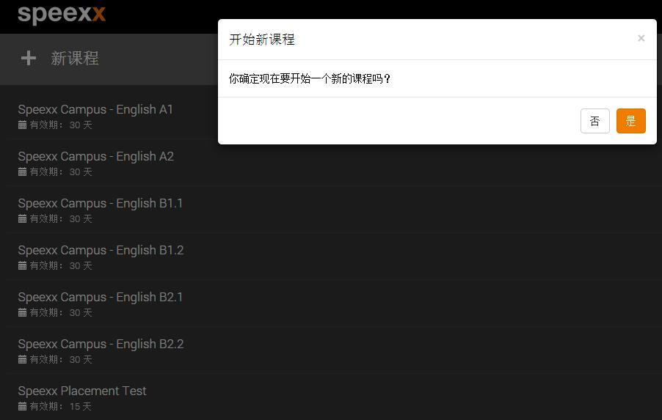

使用说明视频：
http://portal.speexx.cn/static/guidedtour/cn/
注意：如在电脑上使用请先确认以下技术设置
- 确保用户有足够的网络连接宽带，保证速度
- 建议用户使用谷歌的CHRONIE浏览器登录使用
- 若用户使用IE浏览器，确保IE的版本在8以上
- 不建议用国产浏览器登录和使用SPEEXX课程
- 确保电脑自带的话筒或外置话筒正常使用

